Lab Exercise 20
App Deployment Using ECS & ECR

Step 1: Create ECR Repository
- Go to AWS Console
- Search Elastic Container Registry (ECR)
- Click Create Repository
- Give name (example: my-web-app)
- Click Create

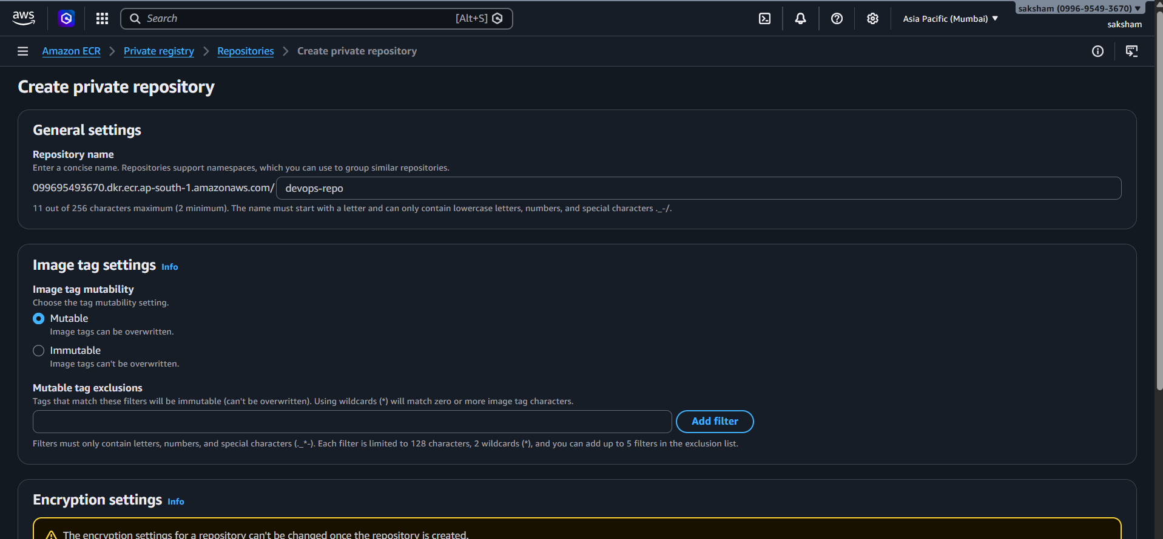
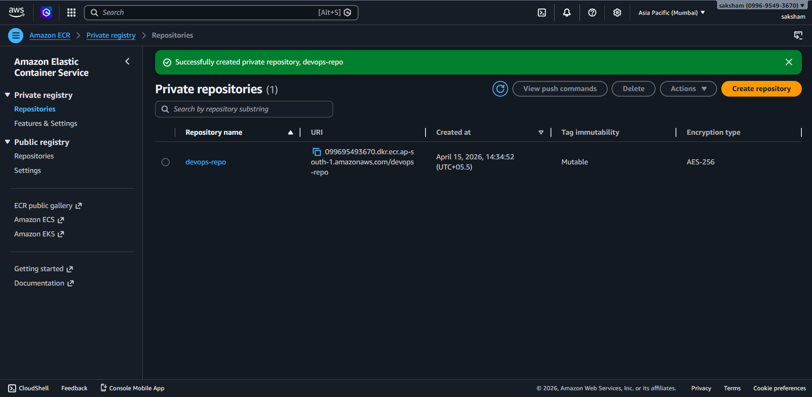

Step 2: Configure aws
Create access key
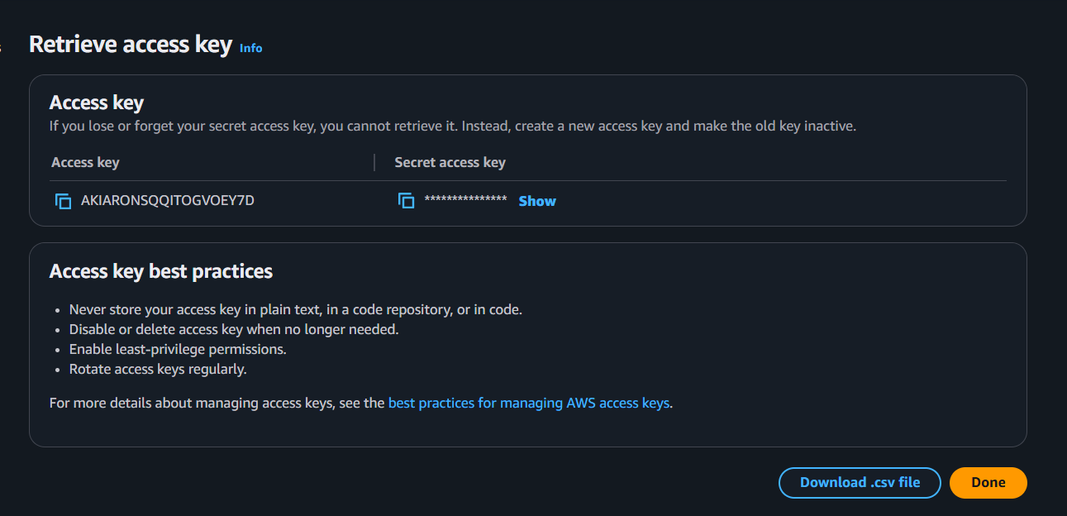

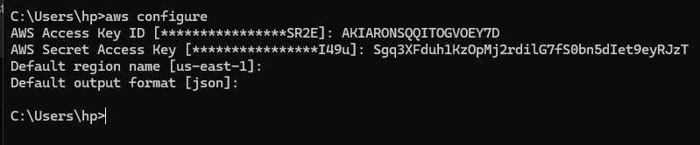
Step 3: Authenticate Docker to ECR
Run this :
aws ecr get-login-password --region ap-south-1 | docker login --username AWS --password-stdin 099695493670.dkr.ecr.ap-south-1.amazonaws.com

Step 4: Build Docker Image
Run this :
docker build -t devops-ecr .

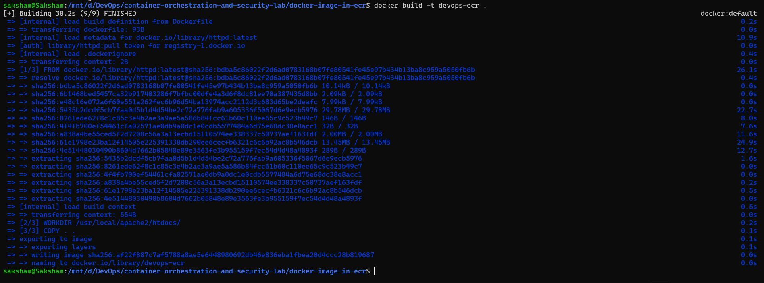
Step 5: Tag Docker Image
Run this :
docker tag devops-ecr:latest 099695493670.dkr.ecr.ap-south-1.amazonaws.com/devops-ecr:demo

Step 6 : Push Docker Image
Run this :
docker push 099695493670.dkr.ecr.ap-south-1.amazonaws.com/devops-repo:latest

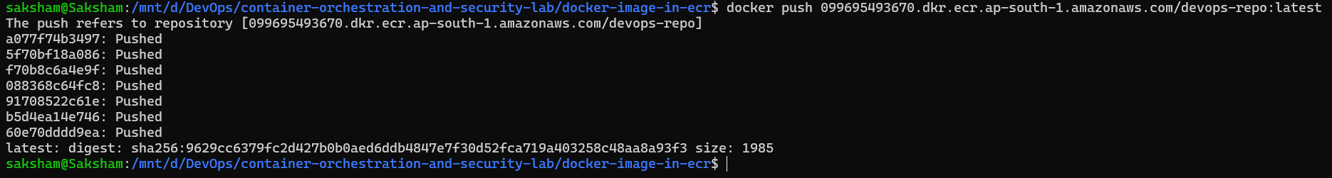
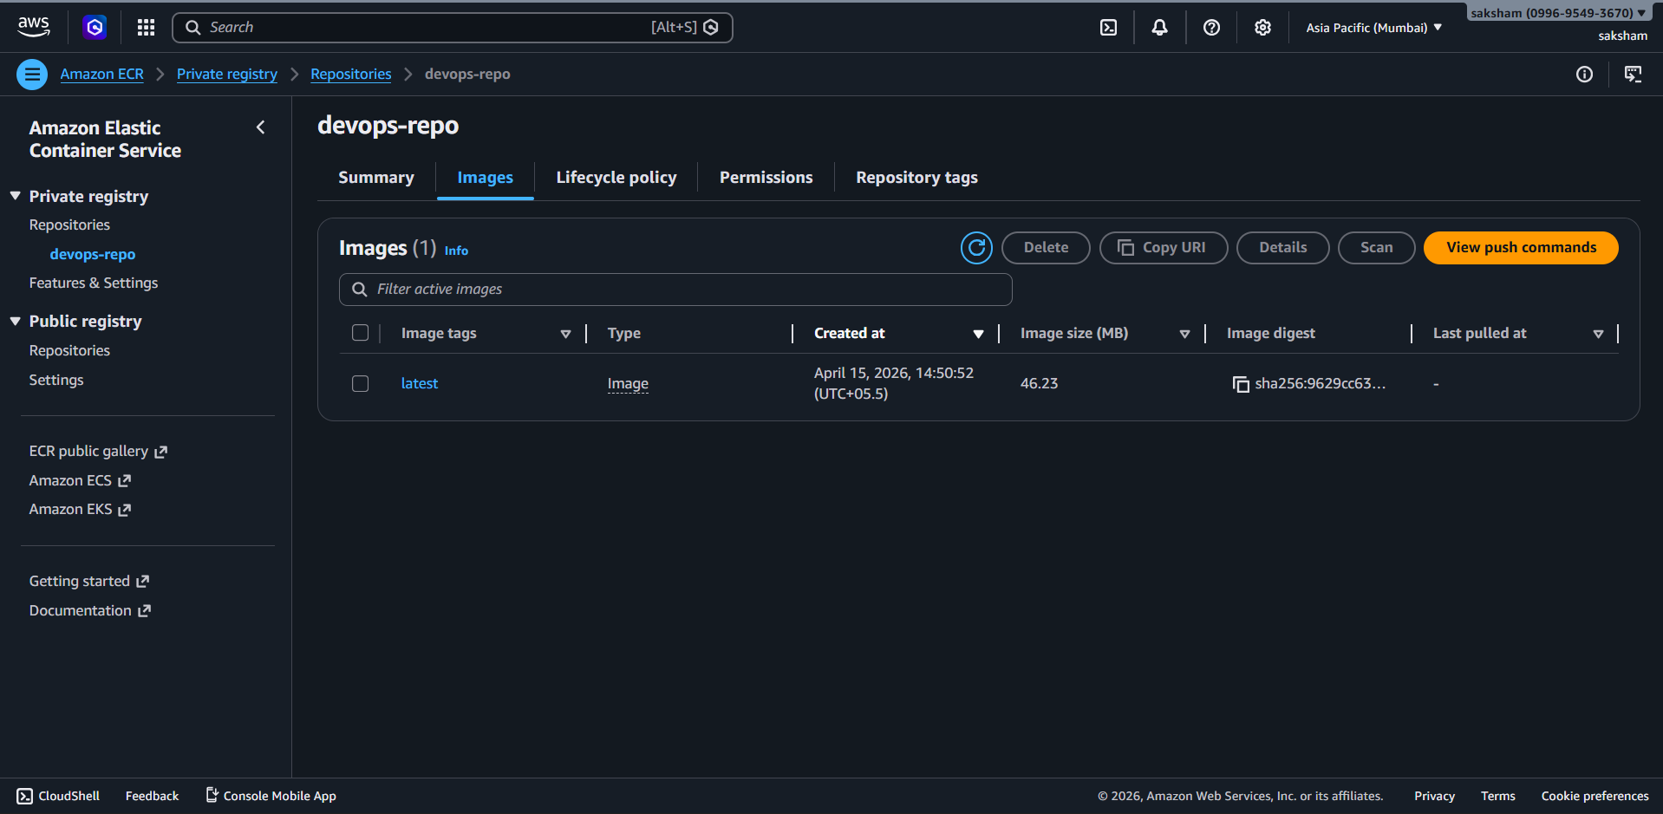

Step 7: Create Cluster
- Go to ECS
- Click Create Cluster
- Select Fargate (Serverless)
- Cluster Name: devops-cluster-new
- Click Create

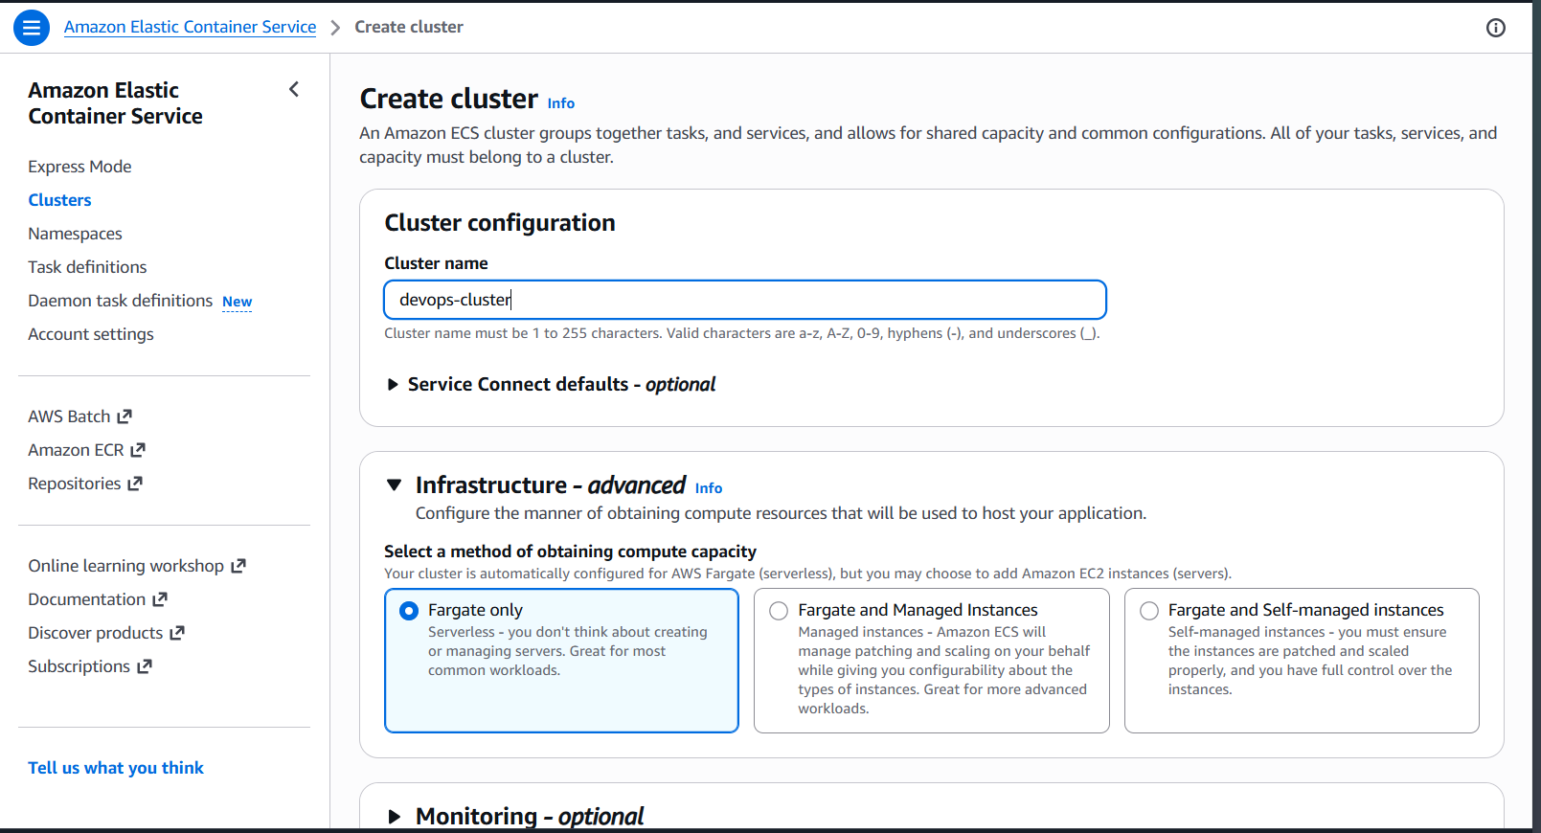

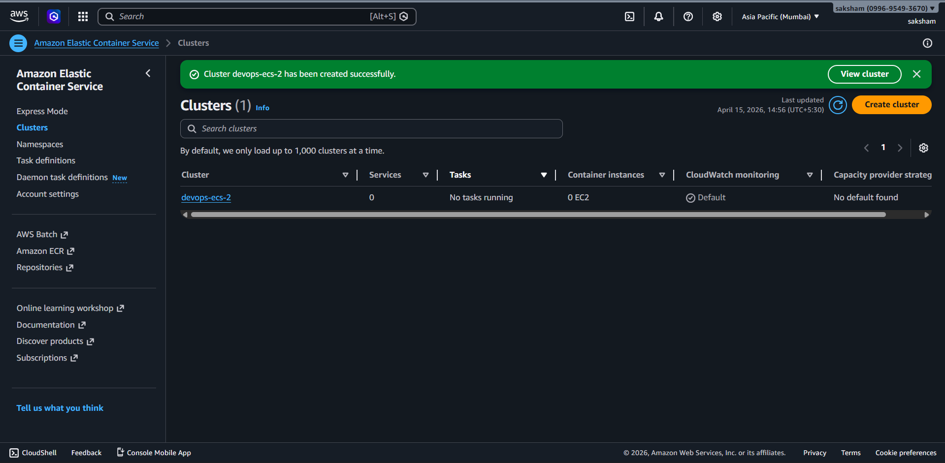

Step 8: Create Task Definition
- Launch Type → Fargate
- Container Image → Paste ECR URI

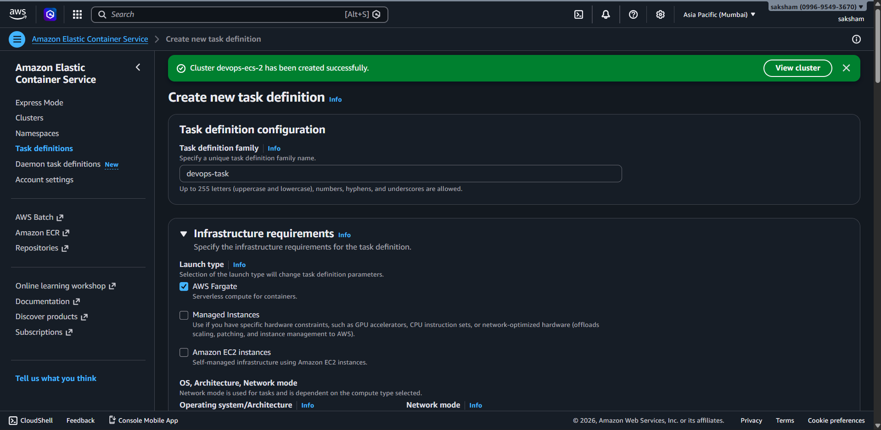
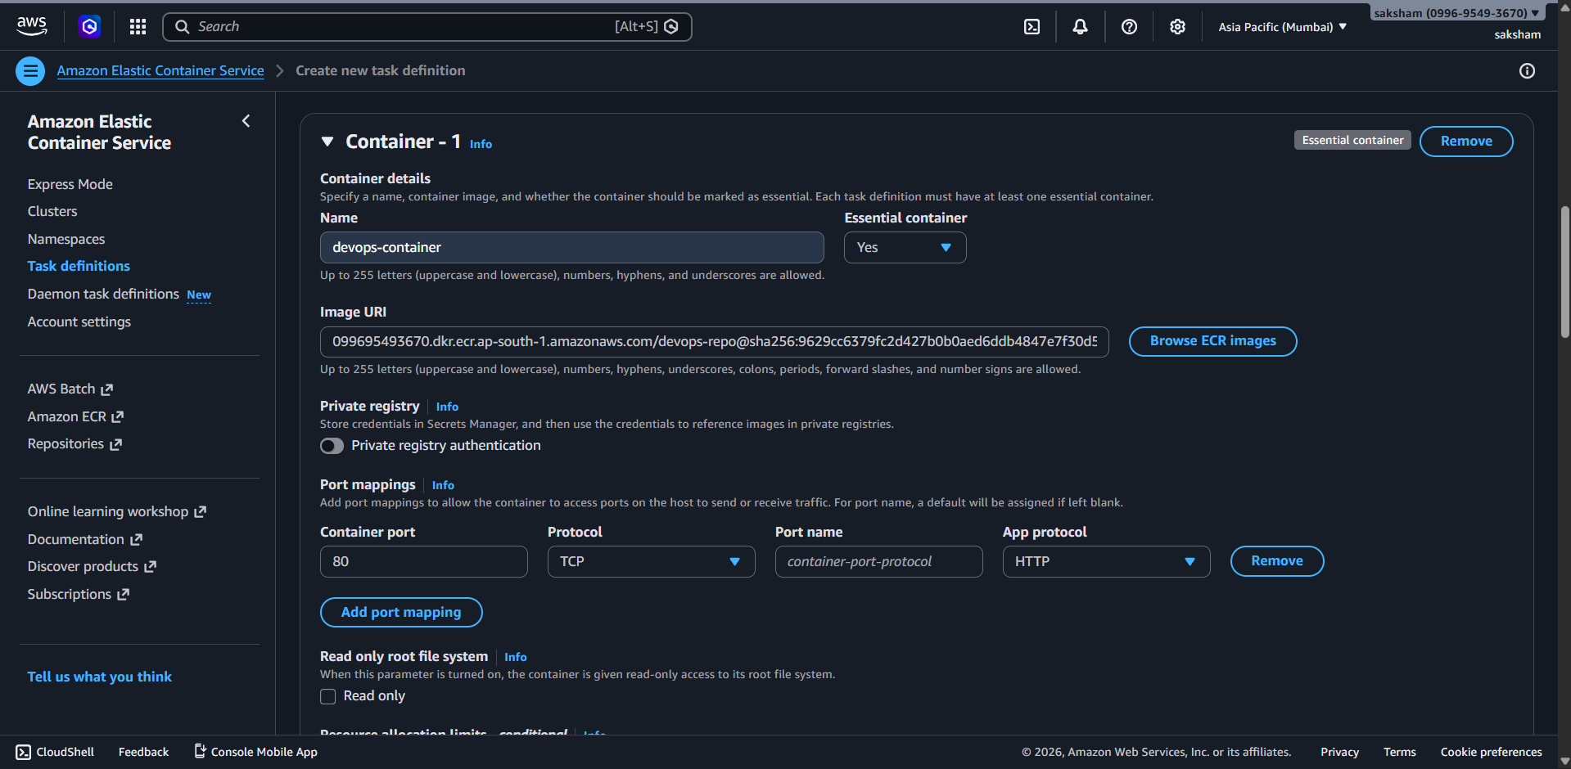

Step 9: Create Service
- Go to Cluster
- Click Create Service

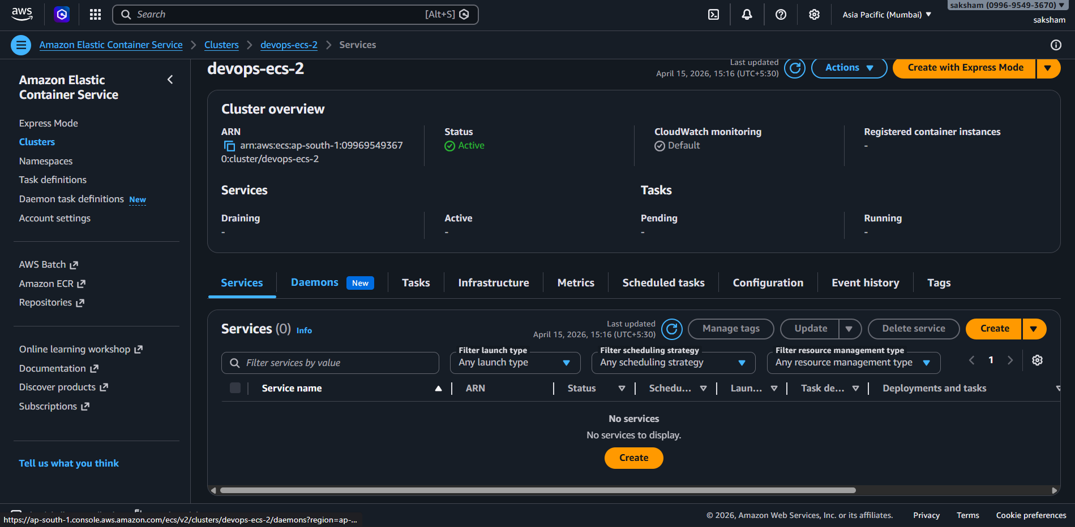

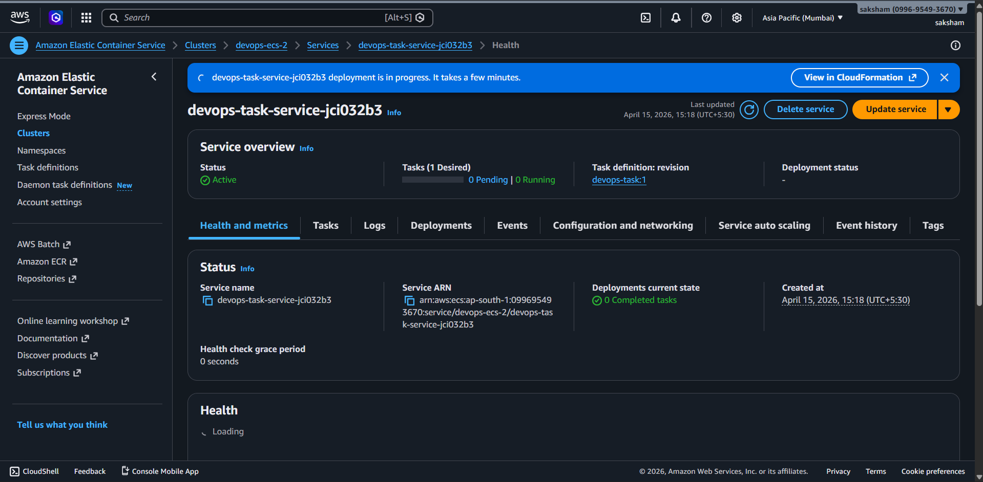

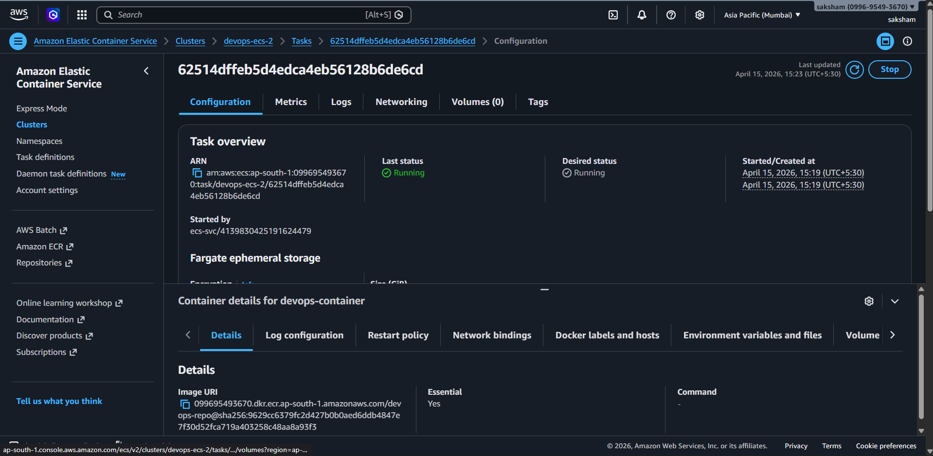

Step 10: Turn on all traffic in security broke
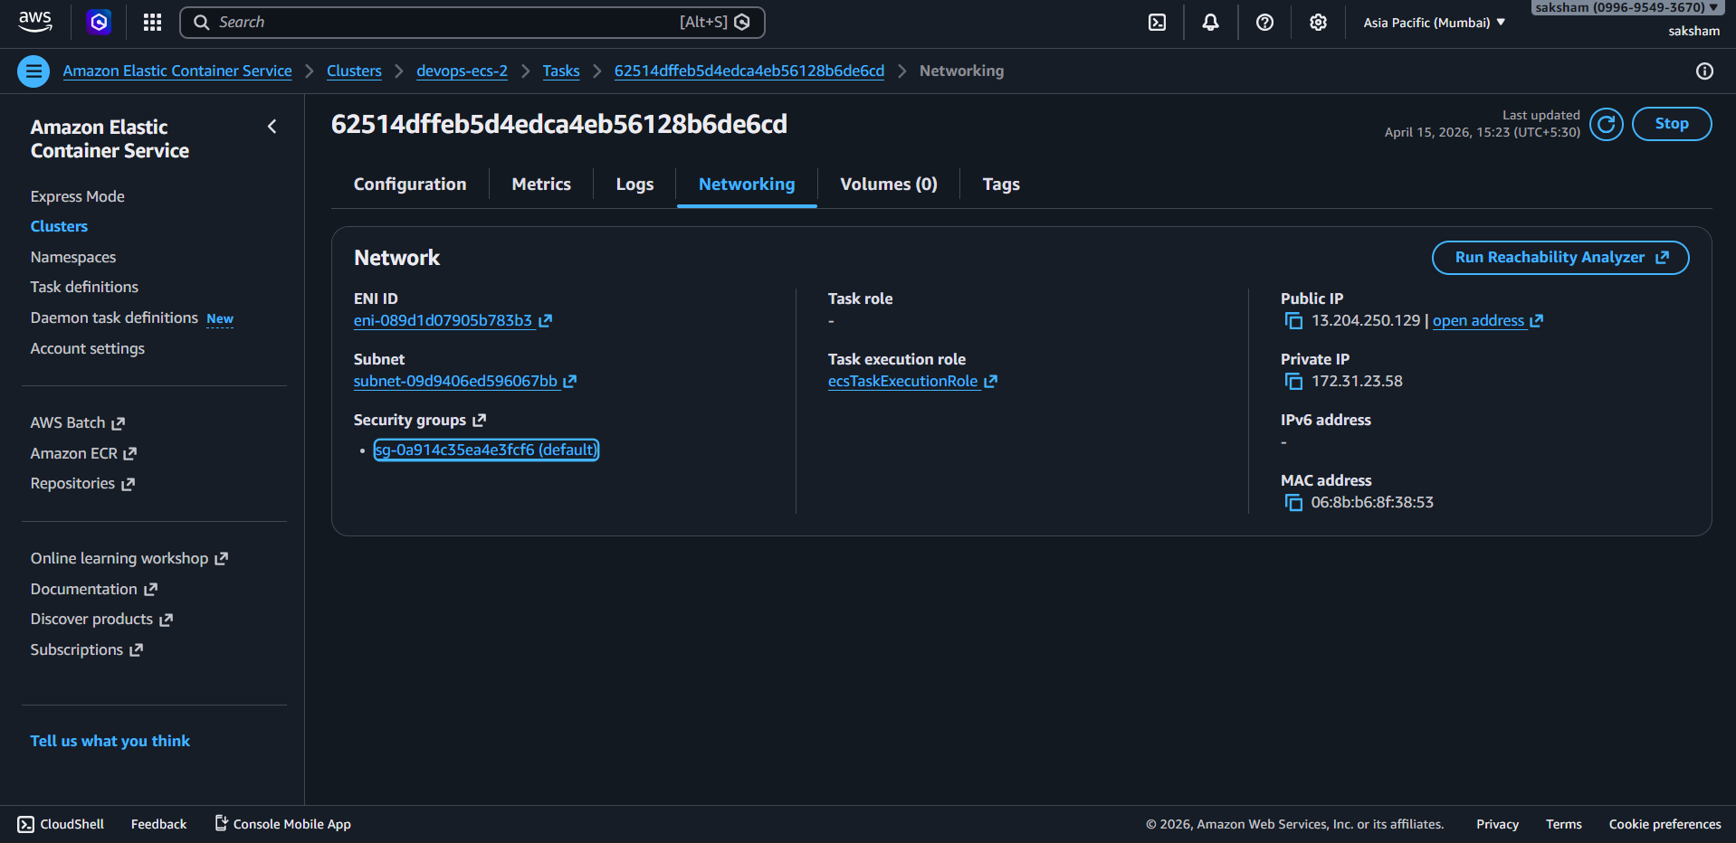
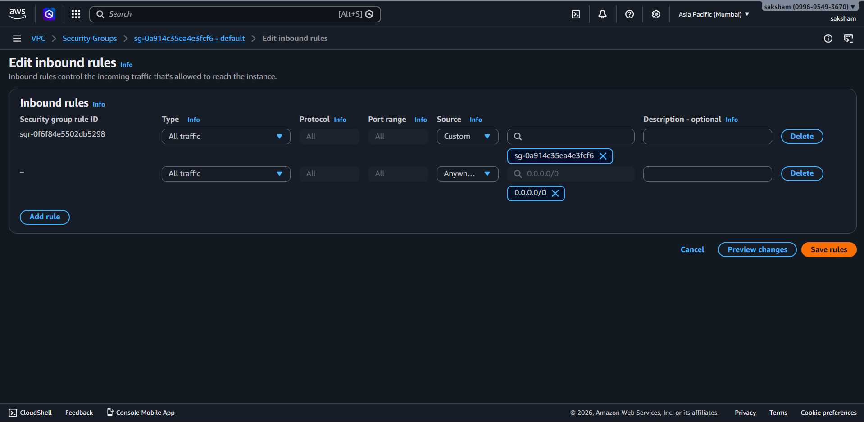

Step 11 : Verify Deployment
- Go to Load Balancer
- Copy DNS Name
- Paste in Browser

http://3.82.48.11/

